The Louisiana State Epidemiological Profile

  - May 2013

Prepared by:
The State Epidemiology Workgroup
And The Cecil J. Picard Center for Child Development and Lifelong Learning
Contents
List of Figures ii
State Epidemiology Workgroup Membership iv
Executive Summary v
The Louisiana State Epidemiological Profile 1
Introduction 1
The Mission of the State Epidemiology Workgroup 1
SEW Data Prioritization 2
Illicit Drugs 3
Alcohol 3
Tobacco 3
The Organization of the Louisiana State Epidemiological Profile 4
Louisiana Population Overview 5
Substance Abuse Indicators 8
Alcohol Indicators 8
Youth Alcohol Indicators 8
Adult Alcohol Indicators 12
Tobacco Indicators 18
Youth Tobacco Indicators 18
Adult Tobacco Indicators 21
Marijuana Indicators 24
Youth Marijuana Indicators 24
Adult Marijuana Indicators 25
Behavioral Health Indicators 27
Mental Health 27
Youth Mental Health Indicators 27
Adult Mental Health Indicators 31
Suicide 32
Youth Suicide Indicators 32
Adult Suicide Indicators 33
Summary and Conclusion 34
Appendix A: Complete List of SEW Data Indicators 35

List of Figures
Figure 1. Louisiana population characteristics compared to US (Source: 2010 US Census Bureau) 6
Figure 2. Percentage of children living at or below the poverty line (Source: US Census Bureau Bureau) 6
Figure 3. Louisiana Poverty rates from 1960 to 2010 (Source: US Census Bureau Bureau) 7
Figure 4. Childhood poverty rates by parish (Source: US Census Bureau Bureau) 7
Figure 5. Trends in alcohol use amongst Louisiana youth in grades 6, 8, 10, and 12 (Source: CCYS) 9
Figure 6. Relative rates of alcohol use by parish for 8th, 10th, and 12th grade students (Source: CCYS 2012) 10
Figure 7. Statewide rates of binge drinking for 6th, 8th, 10th, and 12th grade students (Source: CCYS) 10
Figure 8. Relative rates of binge drinking by parish for 8th, 10th, and 12th grade students (Source: CCYS 2012) 11
Figure 9. Louisiana Statewide Alcohol-related Injury Crash rates (Source: LSU Highway Safety Research Group 2012) 12
Figure 10. Alcohol related vehicle crash injury rates in Louisiana from 2001 to 2011 (Source: Highway Safety Research Group) 13
Figure 11. Alcohol related vehicle crash fatality rates in Louisiana from 2001 to 2011 (Source: Highway Safety Research Group) 13
Figure 12. Comparison of Louisiana to US rates of current drinking from 2001 to 2011 (Source: BRFSS) 14
Figure 13. Rates of current drinking for all states in the US (Source: BRFSS 2011) 14
Figure 14. Comparison of Louisiana to US rates of binge drinking from 2001 to 2011 (Source: BRFSS) 15
Figure 15. Nationwide comparison of adult binge drinking rates (Source: BRFSS 2011) 16
Figure 16. Percentage of individuals that meet the criteria for being classified as abusing or dependent upon alcohol (Source: NSDUH) 17
Figure 17: Percentage of youth reporting cigarette use within the last 30 days from 2002 to 2012 (Source: CCYS) 18
Figure 18. Percentage of youth reporting cigarette use within the last 30 days by parish (Source: CCYS 2012) 19
Figure 19. Percentage of youth reporting heavy cigarette use within the last 30 days from 2002 to 2012 (Source: CCYS) 20
Figure 20. Percentage of youth reporting heavy cigarette use by parish (CCYS 2012) 21
Figure 21. Percentage of adults reporting heavy cigarette use from 2001 through 2011 (Source: BRFSS) 22
Figure 22. Percentage of adults reporting current cigarette use from 2001-2011 (Source: BRFSS) 22
Figure 23. Rates per 100,000 for lung cancer fatalities in Louisiana from 1999 to 2010 (Source: OPH, Center for Records and Statistics) 23
Figure 24. Percentage of youth in Louisiana using marijuana in the past 30 days (Source: CCYS) 24
Figure 25. 30-day use rates for 8th, 10th, and 12th grade students by parish in Louisiana (Source: CCYS 2012) 25
Figure 26. Percentage of adults indicating marijuana use within the past 30 days (Source: BRFSS) 26
Figure 27. Percentage of adults meeting the criteria for drug dependence or abuse (Source: BRFSS) 26
Figure 28. Percentage of Students in 9th-12th Grade Who Reported Feeling So Sad for Two Weeks or More that They Stopped Doing Usual Activities in the Past Year : 2007-2011 (Source: YRBS) 28
Figure 29. Percentage of youth categorized as high in depressive symptoms. (Source: CCYS) 28
Figure 30. Percentage of adults reporting at least one major depressive episode over past year (Sources: NSDUH) 31
Figure 31. The percentage of adults 18 and over estimated to have experienced any mental illness in the past year. (Source: NSDUH) 31
Figure 32. The percentage of adults 18 and over estimated to have experienced a serious mental illness in the past year. (Sources NSDUH) 32
Figure 33. Percentage of Students in 9th-12th Grade Who Reported Making a Suicide Plan in the Past Year: 2007-2011 (Source: YRBS) 32
Figure 34. Percentage of Students in 9th-12th Grade Who Reported Attempting Suicide in the Past Year: 2007-2011 (Source: YRBS) 33
Figure 35. The percentage of adults 18 and over estimated to have seriously thought about suicide in the past year. (Sources: NSDUH) 33

Scan this QR code to access the online repository of all Louisiana
State Epidemiology Workgroup data for
substance abuse prevention and mental health promotion.
http://www.gov.state.la.us/lasocialindicators

State Epidemiology Workgroup Membership

Capital Area Human Services District | Vivian Gettys
Louisiana Commission on Law Enforcement | Opal West
Department of Education | Lillie Burns
Department of Health and Hospitals, Office of the Secretary | Robert Starszak
Office of Behavioral Health, Mental Health | Terri Cochran
Drug Enforcement Administration | Henry Richardson
Louisiana Highway Safety Commission | Cathy Childers
Historically Black Colleges & Universities | Murelle Harrison, Ph.D.
Center Addressing Substance Abuse in Collegiate Communities | Bret Blackmon
Louisiana National Guard | Vacant
Office of Behavioral Health, Prevention | Bill Blanchard
Office of Behavioral Health, Treatment | Ivory Wilson
Office of Elderly Affairs | Vacant
Office of Family Assistance, Program & Policy Section | Stacie Albin
Louisiana State Police | Rebecca Nugent
Office of Public Health, Assistant State Epidemiologist | Susanne Straif-Bourgeois
Office of the Governor, Safe and Drug Free Communities | Missy Graves
Office of Public Health, Infectious Disease Epidemiology | Gary Balsamo, DVM
SEW Project Director, Office of the Governor | Dawn Diez
ULL-Center for Child Development | Gary Asmus, Ph.D.

Executive Summary
The focus of The Louisiana State Epidemiological Profile is on the specific substances prioritized by the State Epidemiology Workgroup (SEW) at the direction of the Drug Policy Board (DPB). Since the inception of the SEW in 2004 the workgroup has gathered substance use and abuse data that consists of 221 distinct indicators. The prioritization process considered all of the measures. The review of these indicators resulted in a focus on youth in general and specifically on alcohol, cigarettes, and marijuana. This profile is focused on presenting the indicators that are most proximal in time and consequence to those substances for youth. Additional indicators are also presented for adults and, particularly, young adults. The young adult population is where many of the problems that began in youth tend to have their most immediate and greatest consequences.
This focus is not intended to minimize or ignore other substances, other age brackets and/or other behavioral health issues. The SEW continues to gather data and expand the number of indicators that are available to state and community planners. All current data is available online at http://www.gov.state.la.us/lasocialindicators. This profile contains the most directly relevant indicators in a condensed format to present the overall picture. It is the intent of the SEW that this report be a starting point for understanding the most important substance use and abuse issues in the state with an expanded focus on related behavioral health issues, specifically suicide and depression. Local community groups can use the online data system to delve more deeply into the consumption and consequences of substance use and abuse and related behavioral health issues.
Consumption indicators for youth indicate a downward trend in both general alcohol consumption and in binge drinking, but for adults the rates are increasing. A comparison to overall consumption rates nationwide reverses the relationship. While the consumption rates for youth are trending down, the rates in Louisiana are still higher than the national rate. The adult rates in the state are trending up, but the overall adult consumption rates are lower than the national average. The most positive indicator is in relation to the immediate consequences as measured by alcohol-related vehicle crash injuries and fatalities. Over the last 10 years, the rate for injuries has decreased 34% and the rate of fatalities has decreased over 35%.
Particularly amongst youth and young adults, the rate of cigarette use has been decreasing over the last 10 years. There has been a 6% decrease in cigarette use within the last 30 days for 12th grade students and the rate of use amongst 6th, 8th, and 10th graders has decreased even more. While the data on young adults is more limited, there is an almost 4% decrease in regular tobacco use and a 3% decrease in 30-day use as reported in the latest CORE Alcohol and Drug Survey. Adult rates had been steadily decreasing over the last 10 years, but the latest results from the Behavioral Risk Factor Surveillance System (BRFSS) indicate a recent increase to nearly the second highest rate reported since 2001. There has also been a slight decrease in the reported lung cancer rates in Louisiana, but given the typical lag between cigarette use and the appearance of lung cancer this is likely more closely related to earlier decreases in tobacco use.
Marijuana is the most commonly used drug within the category of other drugs after alcohol and tobacco. Substances that are regularly reported as growing problems such as methamphetamines (1.7% lifetime use in 12th graders) or prescription drugs (7.2% lifetime use in 12th graders) represent a much smaller rate than that for marijuana (30.3% lifetime use in 12th graders). Measures of marijuana consumption indicate increasing rates of use amongst both youth and young adults. While the Louisiana rates are typically lower than national rates (e.g., 30-day use: 14.6% LA 12th graders Caring Communities Youth Survey (CCYS) vs. 22.6% US 12th graders Monitoring the Future (MTF)), the increase from 11.2% to 14.6% is cause for concern. Adult consumption has remained at relatively stables rates since 2002.

The Louisiana State Epidemiological Profile

Introduction
The State Epidemiology Workgroup (SEW) was created in December of 2004 and is an advisory committee of the Drug Policy Board (DPB). Please note that SEW and SEOW are used synonymously. In the state of Louisiana, we continue to use the term SEW as its name was established in the Drug Policy Board By-laws. The vision of the SEW is: “To recognize that alcohol, tobacco and other drug abuse is a serious social and public health issue that when addressed will create a climate of healthiness and community wellness for all of Louisiana. (Revised November 17, 2005)” (SEW Bylaws).
Toward that end the SEW focused on identifying sources of data related to the consumption and consequences of alcohol, tobacco and other drugs, as well as, related behavioral health issues. The last time that the SEW published a statewide epidemiological profile was in 2009. Concurrently, the SEW supported the development of an online data repository of the indicators and has updated it as new data became available in lieu of a written state epidemiological profile. This current profile was created to address a common issue in the 21st century best captured by paraphrasing the Rime of the Ancient Mariner by Samuel Taylor Coleridge:
“Data, Data, Everywhere
And not a thought to think.”
It is typical in many different fields to exhort practitioners to be “data-driven” and it is also typical to accompany this exhortation with huge volumes of data. The problem in the 21st century is not a lack of data, but instead it is having more data than you know what to do with. This version of The Louisiana State Epidemiological Profile is an attempt to provide not just data or even all of the data, but to, instead, provide the most relevant data for addressing specific, prioritized issues related to substance abuse prevention and mental health promotion. The SEW recognizes that not every reader of this report will have the same priorities as the state, so the most current data on all indicators continues to be available online.

The Mission of the State Epidemiology Workgroup
Initially, the SEW was populated with individuals from a wide range of agencies with a focus on establishing relationships with them so that relevant data could be accessed and made available for substance abuse prevention activities. With the support of the DPB, the SEW was very successful in establishing relationships and gaining access to available data from the agencies. As the SEW matured, the mission evolved from a focus on gathering data to providing recommendations on how to use the data to inform policy and evaluate the outcomes of substance abuse prevention activities.

SEW Data Prioritization
As the mission of the SEW evolved, it became clear to SEW members that to best serve the DPB the SEW should create a prioritized list of substance and associated risk and protective indicators that would be beneficial to both State and community prevention stakeholders. The details of the process that was used are available in Louisiana’s Strategic Plan for Substance Abuse Prevention published in July of 2012, but a brief overview will be presented here. The priorities set in this process are used to focus the content of this profile. While there is substantially more data available from the SEW online data system, this profile is focused on the priorities that were identified.
A subcommittee of the SEW was convened to perform the prioritization process which began with a review of all of the data available based on the SEW’s data gathering activities, with a focus on consumption and consequence data; limited data on related behavioral health issues was available at the time of prioritization. However, data on shared risk factors specific to suicide, depression and mental health from the most recent administration of the CCYS, the Youth Risk Behavioral Survey (YRBS) and the National Survey on Drug Use and Health (NSDUH) is highlighted in the behavioral health section of this profile. The review of the available data determined that the prioritization would include: consideration of consumption and consequence indicators for alcohol, tobacco, and illicit drugs to develop a comprehensive state plan; priority consideration of data available at the parish level; and application of basic epidemiology principles to determine priorities and areas of highest concern. The subcommittee also determined that the best data sources for Louisiana are the CCYS and the CORE Alcohol and Drug Survey funded by the Office of Behavioral Health (OBH).
Members of the SEW subcommittee assessed the data and considered the following questions:
- What are the consumption patterns and consequences of alcohol, tobacco, and other drug use in Louisiana for which epidemiological data is available for all 64 parishes?
- How close is the relationship between the consumption behavior and the consequence?
- How does Louisiana compare to national rates of both consequences and consumption?
- What are the state rate, percentage, and number of cases for each consequence and related consumption behavior?
The SEW subcommittee looked at the various consumption and consequence indicators within each substance category. The subcommittee determined those indicators to be most tractable (malleable) and most proximal to actual substance use, when possible, for each substance. An exception to this principle was including lung cancer mortality for tobacco use. Although lung cancer mortality is not proximal to the actual behavior, the strong association of lung cancer to smoking led to its consideration. Also noted, parishes not participating in the CCYS (Evangeline, St. Bernard and St. Tammany) and parishes not having sufficient public school participation in the CCYS (Orleans) were assigned the state rate when using the CCYS data for this prioritization process.
Members of the SEW subcommittee followed the prioritization process outlined below:
- Prioritize consumption and consequence indicators of most concern for alcohol, tobacco and illicit drugs
- Prioritize parishes (geographic areas) of highest concern for alcohol, tobacco and illicit drugs
Prioritization of substance and population will take place at the regional and community level during the strategic planning process. From the statewide perspective of the SEW the following indicators are listed along with the reasons for their inclusion:

Illicit Drugs
Youth 30 Day Marijuana
- Parish level data available – CCYS
- Significant number of users and people impacted to warrant monitoring
- Gateway drug
- May see a relationship with alcohol use (as alcohol use decreases, marijuana use may increase)
Drug Poisoning Deaths
- Immediate outcome
- Alarming trend and high state to national rate ratio
- Limited parish level data available through SEDS (All parishes potentially available through Louisiana Office of Public Health (OPH)).
- Recommend getting a better understanding of composition of deaths included in indicator

Alcohol
Number of alcohol related vehicle crashes resulting in injuries and fatalities
- Parish level data available – Louisiana Highway Safety Commission
- Immediate outcomes
- High rates of concern
Youth 30 Day Alcohol
- Parish level data available - CCYS
- Disparity between state rates and national rates
- Trend not going down
Youth Binge Drinking
- Parish level data available - CCYS
- Indicator of risky behavior
- Above national rates in all 3 categories (8th grade, 10th grade and 12th grade)

Tobacco
Youth 30 Day Tobacco Use
- Parish level data available - CCYS
- Disparity between state rates and national rates
- Above national rates in all 3 categories (8th grade, 10th grade and 12th grade)
Youth Heavy Cigarette Use
- Parish level data available – CCYS
- Above national rates in all 3 categories (8th grade, 10th grade and 12th grade)
- Heavy Tobacco use, defined as ½ pack or more per day, constitutes concern
Adult Heavy Tobacco Use – College
- Institutions of higher education data available – CORE
- Above national rates
- Heavy Tobacco Use defined as using 3 or more times per week constitutes concern
Adult Daily Cigarette Use
- Only state level data available but data from 3 different surveys allows you to look at the impact on 3 very different populations – Behavioral Risk Factor Surveillance Survey (BRFSS)
- Above national rates
Lung Cancer
- Although lung cancer mortality is not proximal to the actual behavior, the strong association of lung cancer to smoking led to its choice as an indicator
For the purposes of this profile, the data reported here will closely follow the above list of indicators, but will include some additional behavioral indicators that are directly related. The list of indicators above is closely focused on youth indicators with only a handful of adult indicators included. One of the reasons that more adult indicators were not included in the prioritized list was a simple lack of availability of data on the regional and parish levels. While this limitation still holds, the state level data is included for adult indicators to provide additional context for understanding the youth indicators. While still maintaining the youth population targeted via the prioritization process, this state epidemiological profile slightly expands the indicators presented to provide a more expansive view of the shared risk factors between substance use and related mental, emotional and behavioral problems.

The Organization of the Louisiana State Epidemiological Profile
The Louisiana State Epidemiological Profile is organized in relation to the prioritized list of substances. First, there is a section that briefly describes the overall population in the State of Louisiana. This is followed by a section on the substance abuse indicators with separate subsections for alcohol, tobacco, and marijuana. As discussed above, there is more data available than is included here and this is particularly true for other drugs and related behavioral health indicators. Data on both youth and adult consumption of other drugs such as cocaine, prescription drugs, and methamphetamines are available, but the focus of the profile is on the prioritized substances of alcohol, tobacco and marijuana. The prioritization process resulted in a strong focus on youth consumption, but the parallel adult and higher education indicators are also included where available and appropriate. Prevention activities may target youth, but an understanding of the adult consumption and consequence patterns provides an important and relevant context for a focus on youth.
Finally, a note on the conventions that will be used in this report to display data in tables, charts, graphs and maps. Generally, where parish-level data is presented it will come in the form of a map of the state. Each parish will be colored according to the statistical quartile within which they fall. There are 64 parishes/ communities within Louisiana, so there will be 16 parishes that fall within each quartile. Those parishes that fall into one of the two "low risk" quartiles will be shaded in greens while parishes in the two "high risk" quartiles will be shaded in red with darker shades of green and red representing the highest and lowest quartiles. Note that the “low risk” and “high risk” quartiles will vary based on the measure. Sometimes the low rates are good (e.g., alcohol-related traffic crash injuries) while other indicators are better when they are higher (e.g., CCYS Protective Factors). The detailed numbers underlying each map are available online and will not be typically included in this report. Tables, Bar Charts and Line Graphs will also be used to present data. Tables will typically be included with the line and bar graphs. Line graphs will be used to display comparison data over time, while bar graphs will be used to show comparisons of data from single points in time. Tables, charts, and graphs will usually be rounded to the nearest decimal point and specific data points referenced within the text will generally be presented as whole numbers for ease of reading.

Louisiana Population Overview
There are 4,533,372 people living in the state of Louisiana according to the 2010 US Census Bureau. That is a 1.4% increase over the 2000 US Census Bureau population (4,468,976), which while a lower rate of growth than the US as a whole (9.7% increase) is significant in light of the catastrophic diaspora that occurred in 2005 with the impact of Hurricanes Katrina and Rita. The Census population estimates for Louisiana in the year following the storms indicated a total population of 4,287,768, a 4.1% decrease from 2000. The growth between 2006 and 2010 was over 5.7%. No other state in the union has undergone such dynamic changes in population over the same time period.
Even with the unprecedented population shifts caused by the storms, the basic demographics of the state remained relatively stable (see Figure 1). Louisiana is unique in comparison to the nation in that there is a substantially greater percentage of Black/African American residents (32% LA vs. 13% US) and a substantially smaller percentage of Hispanics (4% LA vs. 16% US). Even though the Hispanic population is much smaller in Louisiana it is the faster growing group nearly doubling between the 2000 and the 2010 census (from 2.4% in 2000 to 4.2% in 2010).

Figure 1. Louisiana population characteristics compared to US (Source: 2010 US Census Bureau)
Louisiana remains one of the poorest states with the second highest overall rate of poverty and of children in poverty. The latest available poverty estimates indicate that over 20% of all residents in the state are living at or below the poverty level. Nearly 29% of children in the state are living in households that subsist at or below the poverty line.

Figure 2. Percentage of children living at or below the poverty line (Source: US Census Bureau Bureau)
The statewide poverty rate has decreased substantially over the last 50 years from nearly 40% in 1960 to the current 20%, but Louisiana remains one of the states with the highest poverty rates when compared to the rest of the nation.

Figure 3. Louisiana Poverty rates from 1960 to 2010 (Source: US Census Bureau Bureau)
While the overall statewide childhood poverty rate is near 29%, almost half of the parishes have rates that exceed that. One fourth of the 64 parishes in the state have childhood poverty rates over 34%.
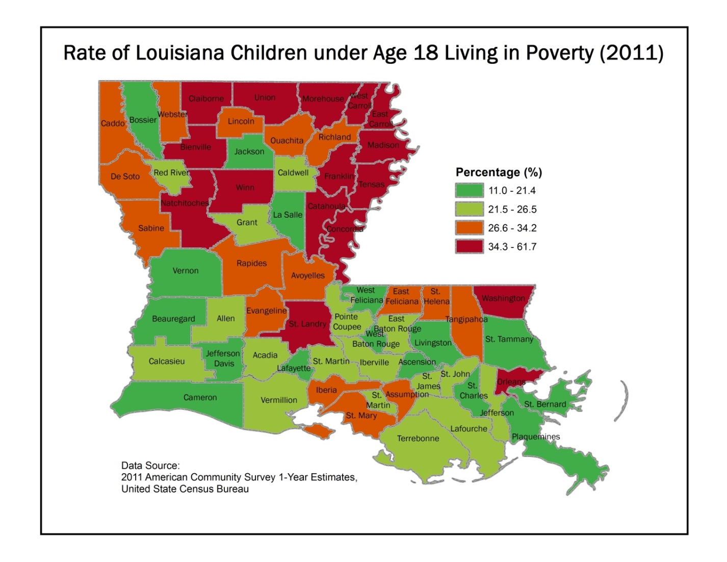
Figure 4. Childhood poverty rates by parish (Source: US Census Bureau Bureau)

Substance Abuse Indicators
This section will present the prioritized indicators of substance abuse in Louisiana. There will be a separate subsection each for alcohol, tobacco and marijuana. The focus of the indicators is on youth, but there will be information on adult rates as available, as well as, behavioral health indicators related specifically to suicide and depression for youth and adult. The main limitation on information related to adults is that data is typically only available at the state level. Using statewide rates for local planning purposes is problematic as communities tend to vary widely across the state. While some parishes have rates that are nearly the same as the statewide rates, others are substantially and meaningfully higher or lower. Regardless, for a complete profile of the state, the statewide numbers for the adult population provides local communities with a useful context within which they can better understand the longer term impacts of the local prevention activities.
It should be noted that the data for young adults from the CORE Alcohol and Drug Survey will be presented in the same sections along with the youth indicators from the CCYS. These two data sources are somewhat parallel in the manner in which use and consequence are measured and provide a natural transition to adulthood. Also, the data indicates increasing rates of usage of all substances that peak in early adulthood and then begin to decrease when measured within older adults. Prevention activities also tend to target both youth and young adults and some research indicates that prevention programs for children have long-term effects that extent beyond the high school years.

Alcohol Indicators
The SEW prioritization process led to the selection of indicators that were focused on youth. As mentioned above, many of the measures are also available for adults, but only on a state-level or, in some cases, on a regional level. Indicators for youth and adults are presented in this section and there are several observations that can be made about rates and trends of consumption and consequences.
Consumption indicators for youth indicate a downward trend in both general alcohol consumption and in binge drinking, but for adults the rates are increasing. A comparison to overall consumption rates nationwide reverses the relationship. While the consumption rates for youth are trending down, the rates in Louisiana are still higher than the national rate. The adult rates in the state are trending up, but the overall adult consumption rates are lower than the national average. The most positive indicator is in relation to the immediate consequences as measured by alcohol-related vehicle crash injuries and fatalities. Over the last 10 years, the rate for injuries has decreased 34% and the rate of fatalities has decreased over 35%.

Youth Alcohol Indicators
Rates of youth alcohol use in Louisiana continue to be higher than the national rates (see Table 1). While the rate of use appears to be trending toward slightly lower rates, the comparison to the nation indicates that students in Louisiana are at least 11% more likely to have used alcohol within the last 30 days.
Table 1. Youth 30-day alcohol use in Louisiana and the US (Source: CCYS 2012 and Monitoring the Future 2012)
Grade Level | Louisiana | USA | LA:USA Ratio
Grade 8 | 18.5 | 11.0 | 1.68
Grade 10 | 35.0 | 27.6 | 1.27
Grade 12 | 45.8 | 41.5 | 1.10

Figure 5 indicates that there may be a slight downward trend in the rate of youth alcohol use over the past decade, but the fact that the rates in Louisiana are substantially higher than the nation points toward youth alcohol use still being an issue that should be addressed as a priority area for prevention activities.

Figure 5. Trends in alcohol use amongst Louisiana youth in grades 6, 8, 10, and 12 (Source: CCYS 2012)
Inspection of the maps in Figure 6 indicates that southern Louisiana parishes tend to have higher rates of alcohol use that becomes more prominent as children reach 12th grade. The usage rates in northern parishes may well be lower than those in the south, but there are a number of parishes that still exceed the national average. Reducing the rate of youth alcohol use remains a priority for Louisiana.
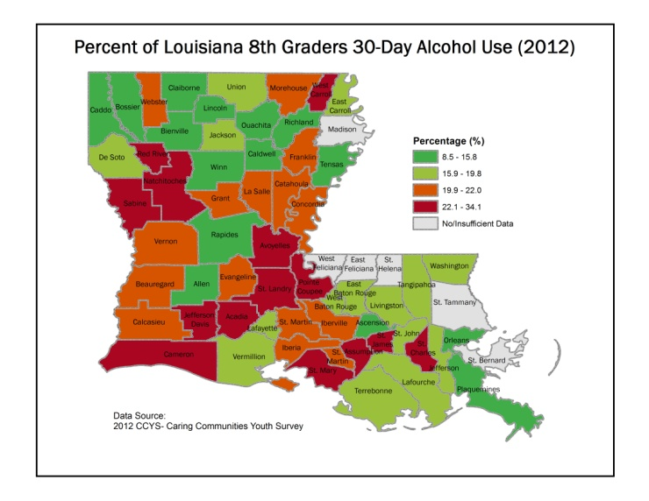 | 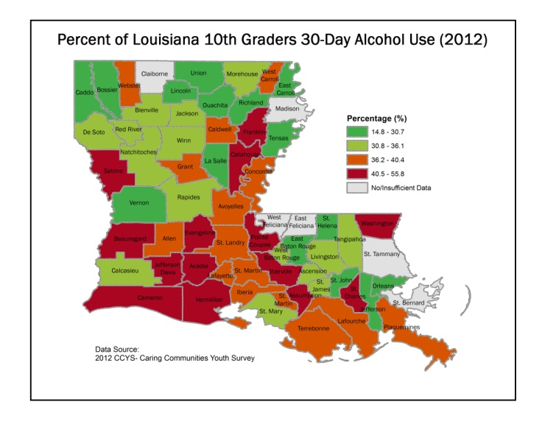
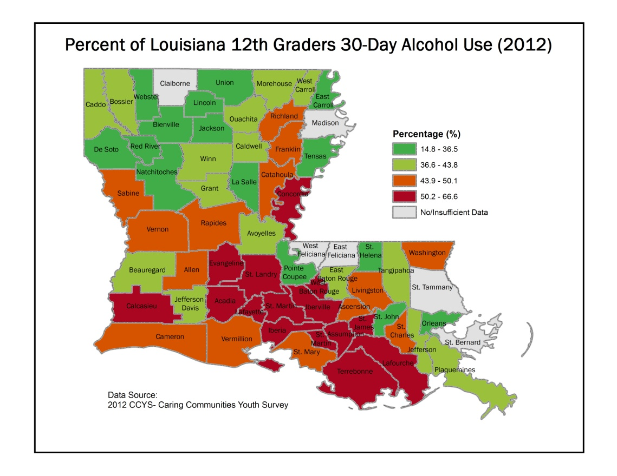
Figure 6. Relative rates of alcohol use by parish for 8th, 10th, and 12th grade students (Source: CCYS 2012)
The trend in the rates of binge drinking amongst youth is very similar to the rates of drinking overall (see Figure 8). There is, perhaps, a more pronounced downward trend in binge drinking than overall drinking for Louisiana youth, but again the state rates are higher than the national rates.

Figure 7. Statewide rates of binge drinking for 6th, 8th, 10th, and 12th grade students (Source: CCYS)
Figure 8 contains the maps of parish level rates of binge drinking across the state and these are also similar to what was evident in the overall rates of youth drinking. Specifically, the southern parishes tend to have higher rates of binge drinking in comparison to the more northern parishes and the differences appear more prominently in later grades. For local prevention practitioners, these results may be indicative of differing cultural norms across that state. Local prevention practitioners will need to consider local rates of youth alcohol use and binge drinking to ensure that selected prevention activities are sensitive to and appropriate for the cultural norms of the community.
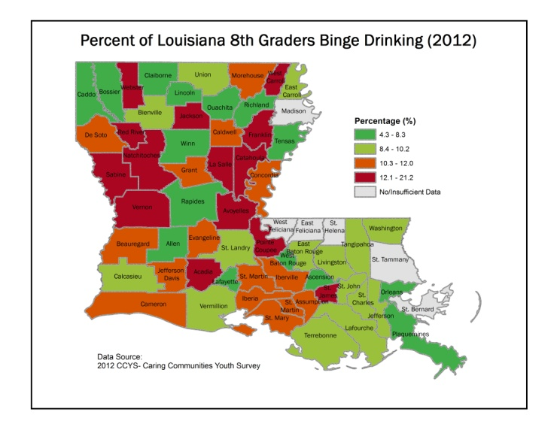 | 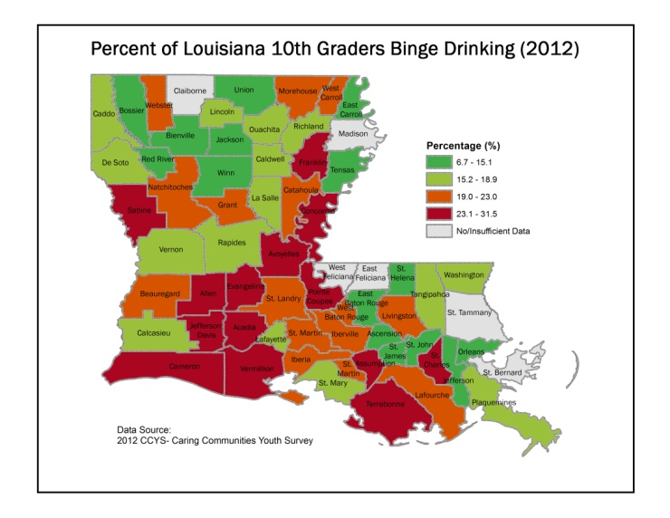
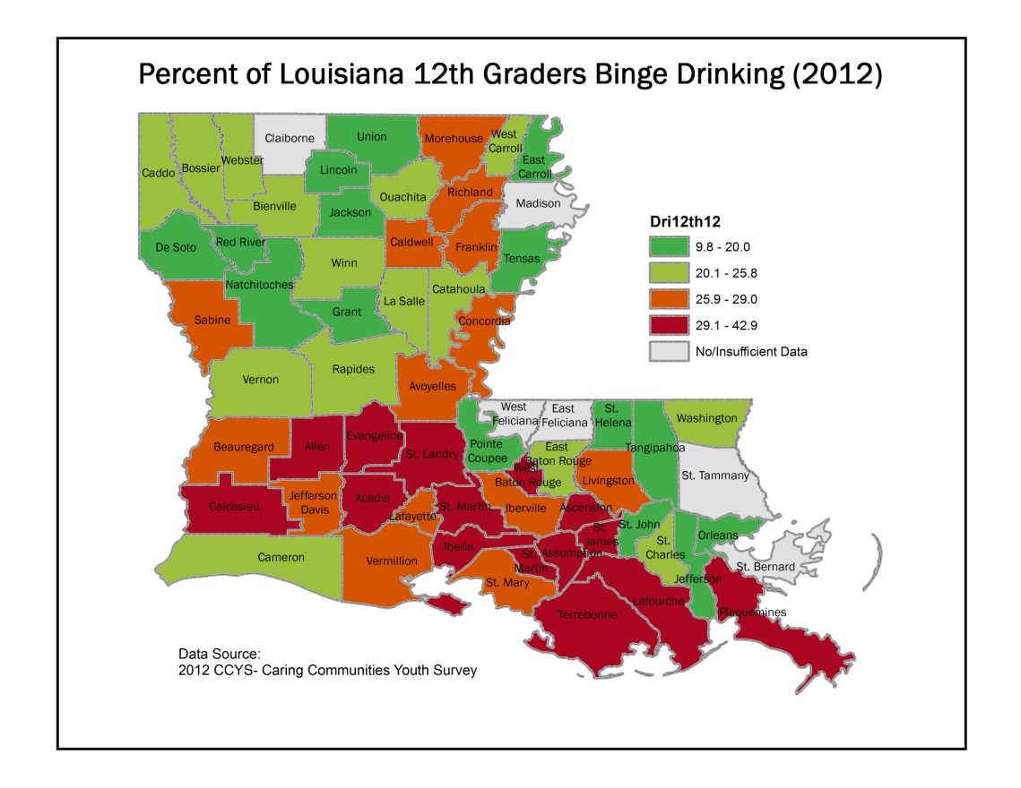
Figure 8. Relative rates of binge drinking by parish for 8th, 10th, and 12th grade students (Source: CCYS 2012)
One of the reasons that there is a continued focus on preventing underage drinking is that higher rates of youth alcohol use are indicative of higher rates of use as youths become adults. The underage rates increase as youth become young adults and this population has the highest rate of negative consequences related to alcohol abuse. For example, the highest rate of alcohol-related vehicle crash injuries is for young adults in the 21-24 age bracket (see Figure 9). The next two age groups with the highest rates are 18-21 and 25-34. A similar pattern holds for alcohol-related vehicle crash fatalities.

Figure 9. Louisiana Statewide Alcohol-related Injury Crash rates (Source: LSU Highway Safety Research Group 2012)

As shown in Table 2, rates of recent alcohol use and of binge drinking are substantially higher for higher education than it is for 12th grade students. Nearly two thirds of the higher education population has used alcohol within the past 30 days, regardless of whether they are underage, and over one third report binge drinking within the last two weeks. Prevention activities that focus on youth and young adults have a greatest chance of influencing the consumption and consequences of alcohol use overall.

Table 2. Higher Education Alcohol Usage Compared to 12th Grade Rates (Sources: CORE 2009, 2011; CCYS 2012)
Higher-Ed Alcohol Usage (CORE Survey) | 2009 | 2011 | 12th Grade 2012
Higher Ed-Underage Alcohol Use-30-Day | 61.1 | 60.2 | NA
Higher Ed-Alcohol Use-30-Day | 64.1 | 62.6 | 45.8
Higher Ed-Binge Drinking Past 2 Weeks | 36.6 | 36.0 | 25.9

Adult Alcohol Indicators
The indicators for the adult population indicate that there may be some improvement in measures of the more immediate consequences of alcohol consumption. As shown in Figure 10, the rate of alcohol-related vehicle crash injuries has decreased over 34% from 2001 to 2011. A similar decrease is seen in alcohol-related crash fatalities (Figure 11).

Figure 10. Alcohol related vehicle crash injury rates in Louisiana from 2001 to 2011 (Source: Highway Safety Research Group)

Figure 11. Alcohol related vehicle crash fatality rates in Louisiana from 2001 to 2011 (Source: Highway Safety Research Group)
In contrast to the indicators of consequences, the rates of both current alcohol use and of binge drinking within the last 30 days have seen a slight increase. There has been a nearly 5% increase in the rate of current drinking for adults in Louisiana, but that rate is still over 7% lower than the national rate (Figure 12). While the national rate has also increased, the Louisiana increase (+4.7%) is over three times larger than the increase nationally (+1.3%). Even with the greater increase in Louisiana, rates of current drinking are lower than the national rate and fall into the bottom fourth when compared to all other states (Figure 13).

Figure 12. Comparison of Louisiana to US rates of current drinking from 2001 to 2011 (Source: BRFSS)
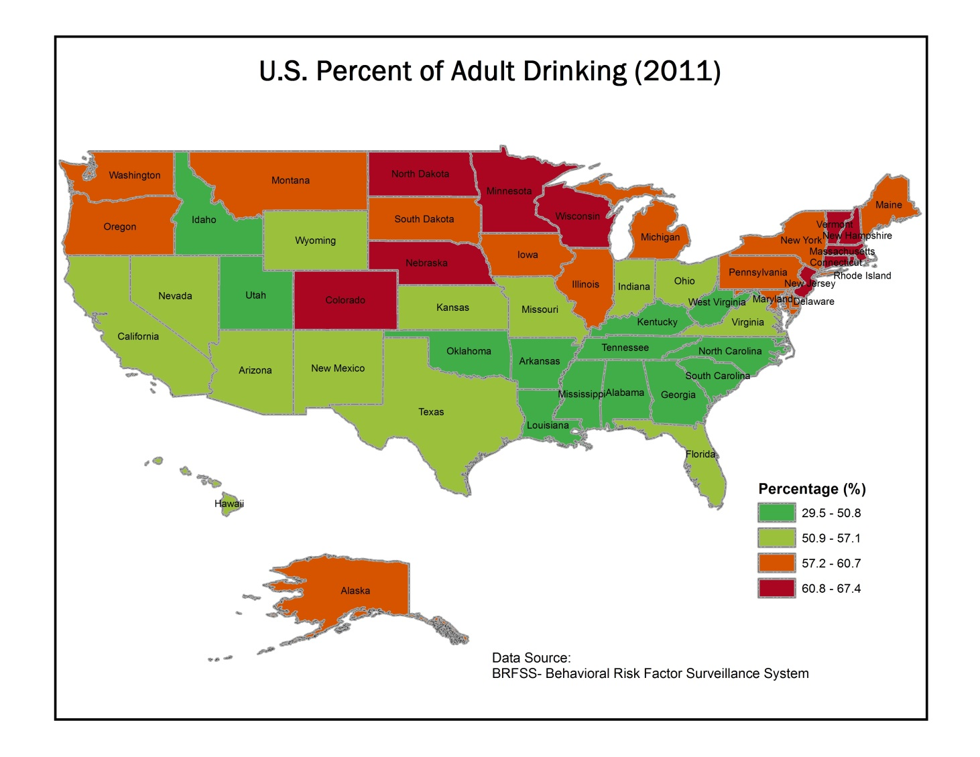
Figure 13. Rates of current drinking for all states in the US (Source: BRFSS 2011)
Similarly, the rates of binge drinking (Figure 12) in Louisiana have increased to 16.1% in 2011 from 13.8% in 2001. The national rate has also increased: from 14.8% in 2001 to 18.3% in 2011. While the increase nationally is greater than in Louisiana, the rates both nationally and within the state have been relatively stable from 2001 to 2010. There is a substantial change nationally and in Louisiana in 2011.

Figure 14. Comparison of Louisiana to US rates of binge drinking from 2001 to 2011 (Source: BRFSS)
As seen in the rates of current drinking, the Louisiana rate for binge drinking (16.1%) is lower than the overall national rate (18.3%). This rate also places Louisiana in the bottom fourth when compared to all states (Figure 15).
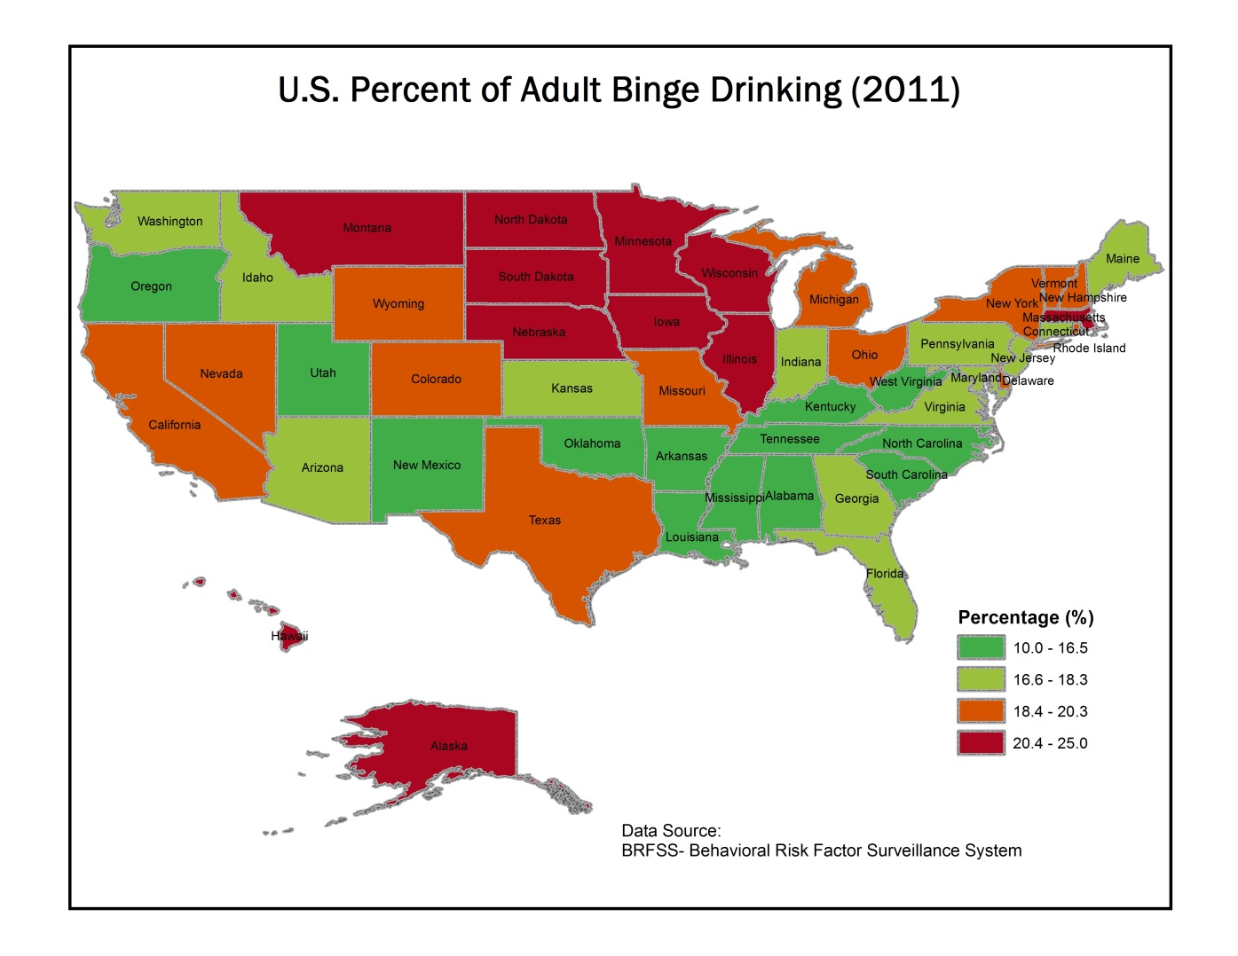
Figure 15. Nationwide comparison of adult binge drinking rates (Source: BRFSS 2011)
While the rates of drinking in Louisiana are generally lower than national rates, the rate of drinking and driving is higher (Table 3). The percentage of Louisiana adults who reported that they have driven after having had too much to drink has been consistently reported at higher rates than the nation over the past decade.
Table 3. Percentage of adults reporting driving after having perhaps too much to drink in the past 30 days from 2002 through 2010. (Source: BRFSS)
Drinking and Driving | 2002 | 2004 | 2006 | 2008 | 2010
Louisiana | 2.4 | 2.5 | 3.3 | 2.6 | 2.8
United States | 2.3 | 2.0 | 2.7 | 2.1 | 1.9

One final measure may indicate that there is some improvement in the rate of alcohol dependence amongst the adult population in Louisiana. Between 2003 and 2009 there was a 1% decrease in the rate of adults identified as dependent on alcohol according to the National Survey on Drug Use and Health (NSDUH), see Figure 16. While there was a small (0.2%) decrease in the national rate, the change in Louisiana brought the state from being higher than the national rate in 2003 to being lower than the nation by 2009.

Figure 16. Percentage of individuals that meet the criteria for being classified as abusing or dependent upon alcohol (Source: NSDUH)

Tobacco Indicators
Particularly amongst youth and young adults, the rate of cigarette use has been decreasing over the last 10 years. There has been a 6% decrease in cigarette use within the last 30 days for 12th grade students and the rate of use amongst 6th, 8th, and 10th graders has decreased even more. While the data on young adults is more limited, there is an almost 4% decrease in regular tobacco use and a 3% decrease in 30-day use as reported in the latest CORE Alcohol and Drug Survey. Adult rates had been steadily decreasing over the last 10 years, but the latest results from the BRFSS indicate a recent increase to nearly the second highest rate reported since 2001. There has also been a slight decrease in the reported lung cancer rates in Louisiana, but given the typical lag between cigarette use and the appearance of lung cancer this is likely more closely related to earlier decreases in tobacco use.

Youth Tobacco Indicators
As shown in Figure 17, there has been a steady decrease for all grades survey in the CCYS in the use of cigarettes since 2002. This trend is also evident in national rates of youth smoking and Louisiana’s rates are very close to them (e.g., 19.7% in LA 12th graders vs. 19.2% nationally (MTF)).

Figure 17: Percentage of youth reporting cigarette use within the last 30 days from 2002 to 2012 (Source: CCYS)
The maps in Figure 18 indicate that the rates vary across the state being fairly evenly distributed across the state. Rates do appear to be higher in more rural areas as most of the largest metropolitan areas in Louisiana appear to have rates that that fall into the lower two quartiles. There is a long history of research documenting higher rates of tobacco use in rural areas.
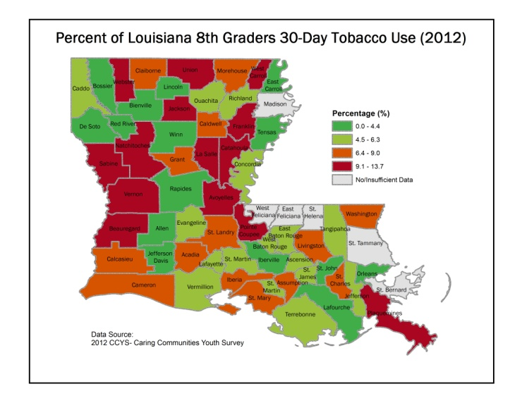 | 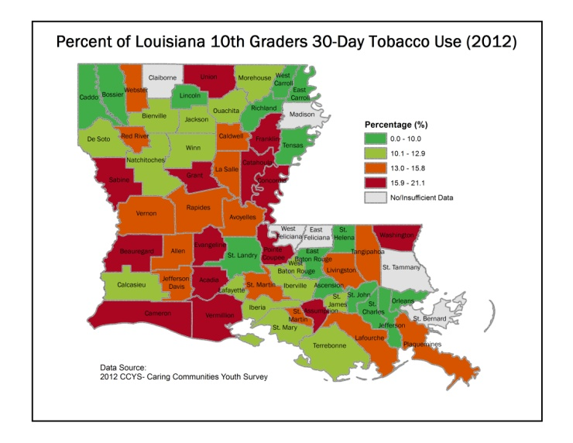
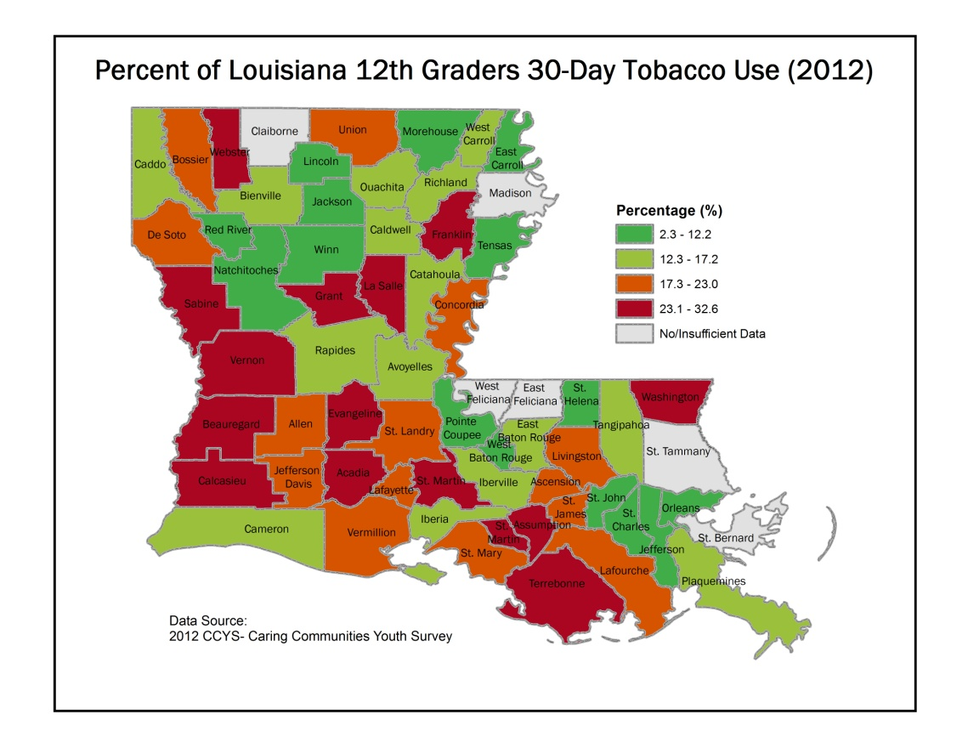
Figure 18. Percentage of youth reporting cigarette use within the last 30 days by parish (Source: CCYS 2012)
Figure 19 displays the rates of heavy cigarette use for youth in 6th, 8th, 10th and 12th grades. Similar to the rates for 30-day use, these rates have been steadily declining since 2002. Even with the steady decline, the rates of heavy use within the state exceed the national rates (e.g., 5.8% LA 12th Grade vs. 4.7% US 12th Grade (MTF)).

Figure 19. Percentage of youth reporting heavy cigarette use within the last 30 days from 2002 to 2012 (Source: CCYS)
Figure 20 displays the rates of heavy cigarette use by parish as measured by the CCYS in 2012. Again usage rates are distributed across the state with an apparent bias toward heavier use in rural areas. There is also some indication that use rates for young adults has recently decreased. Based on the CORE Alcohol and Drug Survey conducted at institutes of higher education, the rate of reported heavy use (3 or more times within the past week) has decreased from 20.3% in 2009 to 16.8% in 2011. Similarly, the rates of use within the past 30 days also show a decrease from 28.1% in 2009 to 25.1% in 2011. The young adult numbers should be considered judiciously due to the large expansion in the sampled institutions between 2009 and 2011.
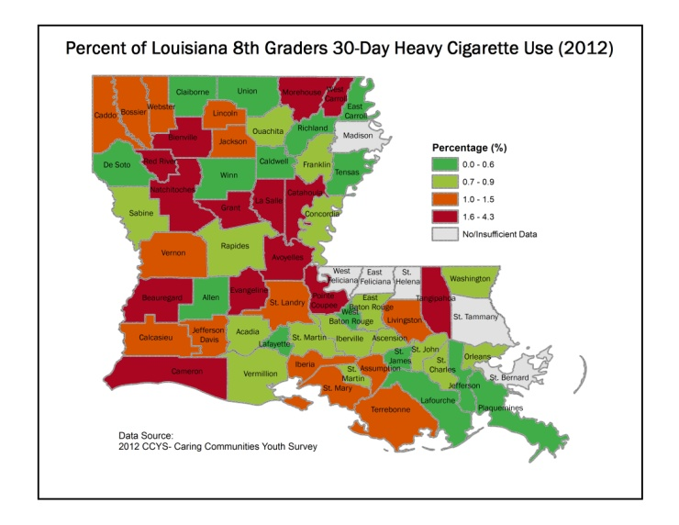 | 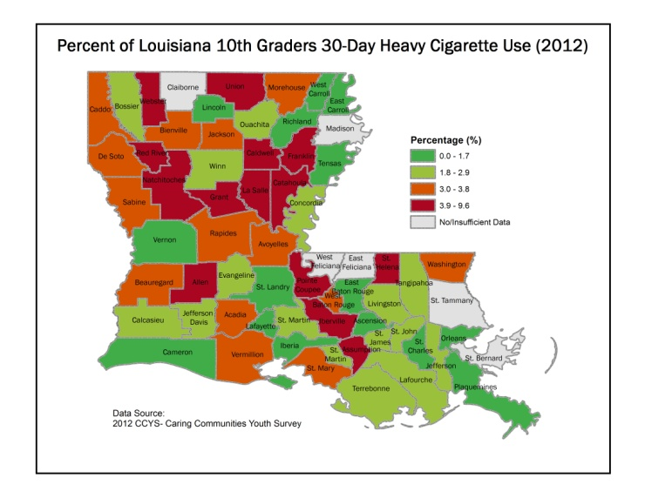
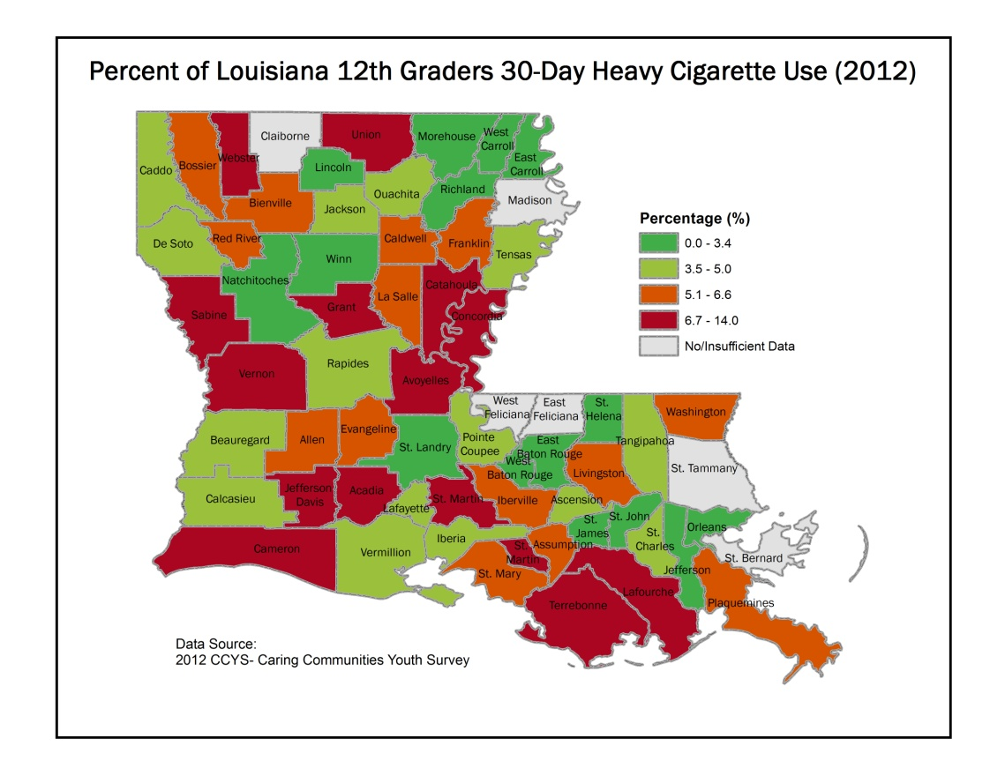
Figure 20. Percentage of youth reporting heavy cigarette use by parish (CCYS 2012)

Adult Tobacco Indicators
Until the most recent results available for adult tobacco use, the trend was very similar to the trends for youth and young adults. There had been a slow, steady decrease in heavy cigarette use from 2001 through 2010, but there was a sharp increase in the reported rates in the 2011 BRFSS (Figure 21). Rates increased within Louisiana and nationally, which is most likely related to the methodological changes that were implemented within the BRFSS to account for a substantial shift in US household to having only cell phones and no landlines.

Figure 21. Percentage of adults reporting heavy cigarette use from 2001 through 2011 (Source: BRFSS)
Figure 22 displays a similar trend in current cigarette use in Louisiana and the nation. There has been a general decrease in use, but the last year of available data show a slight increase again likely attributable to the change in sampling methodology for the BRFSS. Even considering that the rate in Louisiana has been on a downward trend, the rate of adult cigarette use in the state exceeds the national average.

Figure 22. Percentage of adults reporting current cigarette use from 2001-2011 (Source: BRFSS)
One of the challenges to preventing the use of tobacco and reducing the current rates is that the consequences of tobacco use tend to be very distant in time from initiating the habit. One well-known consequences of smoking is lung cancer. There is some evidence that there is a slight decrease in the rate of lung cancer in Louisiana, but that decrease is almost certainly more closely related to reduction in smoking rates from 20 or more years ago. Regardless of the timing, a reduction in lung cancer is welcome.

Figure 23. Rates per 100,000 for lung cancer fatalities in Louisiana from 1999 to 2010 (Source: OPH, Center for Records and Statistics)

Marijuana Indicators
Marijuana is the most commonly used drug within the category of other drugs after alcohol and tobacco. Substances that are regularly reported as growing problems such as methamphetamines (1.7% lifetime use in 12th graders) or prescription drugs (7.2% lifetime use in 12th graders) represent a much smaller rate than that for marijuana (30.3% lifetime use in 12th graders). Measures of marijuana consumption indicate increasing rates of use amongst both youth and young adults. While the Louisiana rates are typically lower than national rates (e.g., 30-day use: 14.6% LA 12th graders (CCYS) vs. 22.6% US 12th graders (MTF)), the increase from 11.2% to 14.6% is cause for concern. Adult consumption has remained at relatively stable rates since 2002.

Youth Marijuana Indicators
As show in Figure 24, there has been an increase in the rates of 30-day marijuana consumption across all grades surveyed in the CCYS.

Figure 24. Percentage of youth in Louisiana using marijuana in the past 30 days (Source: CCYS 2012)
Figure 25 shows the rates of 30-day marijuana use amongst 8th, 10th, and 12th grade students in Louisiana for 2010. There is some indication that rates may be higher in the southern and urban areas of the state, but the maps also indicate that marijuana use is widespread across the state.

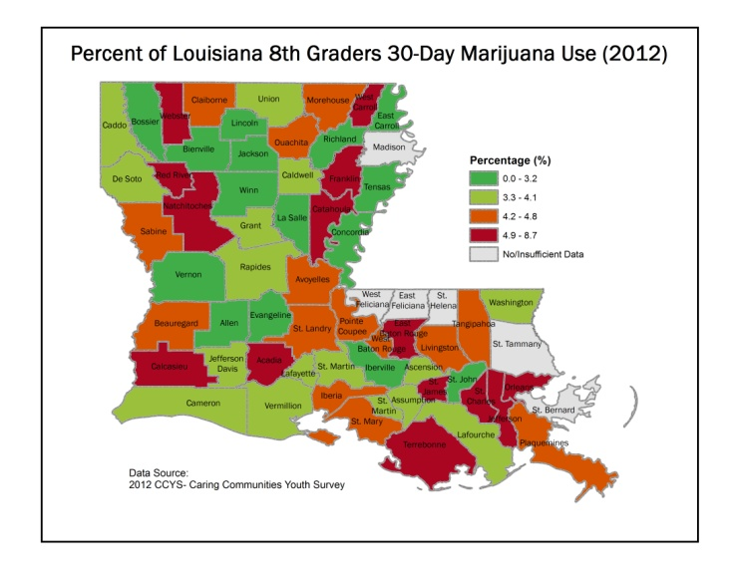 | 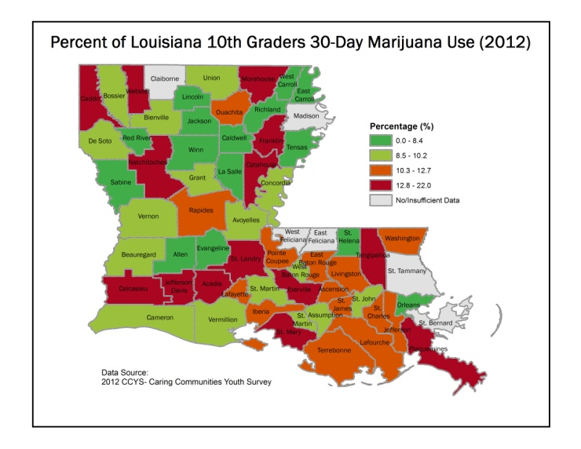
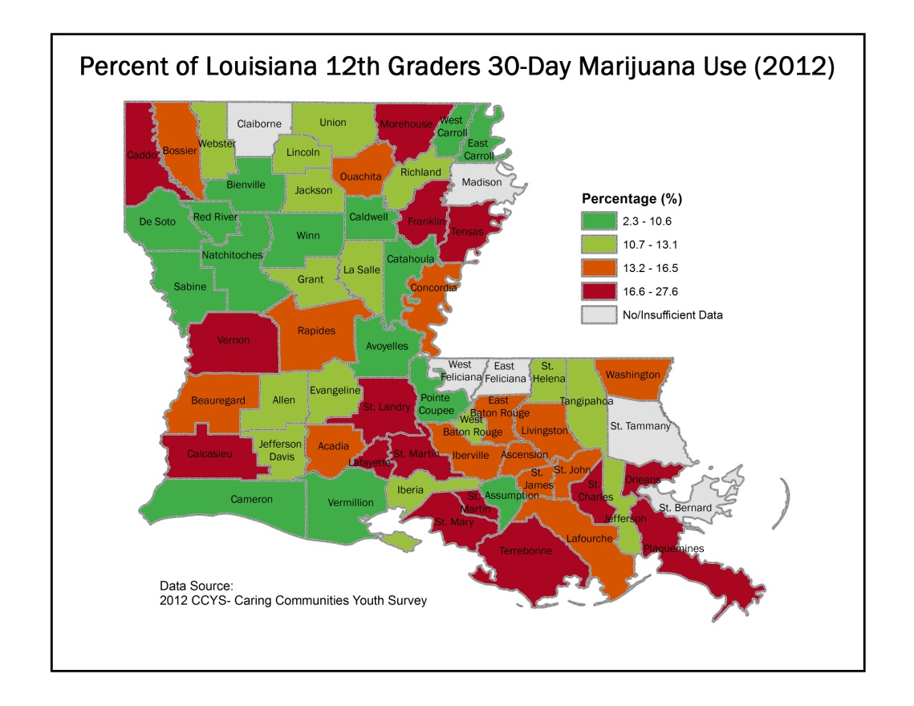
Figure 25. 30-day use rates for 8th, 10th, and 12th grade students by parish in Louisiana (Source: CCYS 2012)
The results from the CORE Alcohol and Drug Survey also indicate that 30 day use has increased from 14.5% of college students to 16.3% of college students between 2009 and 2011.

Adult Marijuana Indicators
The adult consumption rates for marijuana have remained fairly steady both within the US and in Louisiana. The rate in Louisiana has typically been about 1% lower than the national rate and neither has substantially changed since 2004 (Figure 26).

Figure 26. Percentage of adults indicating marijuana use within the past 30 days (Source: BRFSS)
Similarly, the rate of individuals that meet the criteria for being drug abusers or drug dependent has remained approximately the same with a slight downward trend (Figure 27).

Figure 27. Percentage of adults meeting the criteria for drug dependence or abuse (Source: BRFSS)

Behavioral Health Indicators
The field of substance abuse prevention has long recognized that there is substantial overlap between substance abuse and mental health issues. Behavioral health has been defined as a state of mental or emotional being or choices and actions that affect wellness. Substance abuse and use are one set of behavioral problems, but others also include serious psychological distress, suicide and mental illness. While long recognizing the co-occurrence of substance abuse and mental health issues, the field of prevention is also beginning to understand that the risk and protective factors that contribute to both also overlap substantially.
Information from the 2009 NSDUH can be used to illustrate this relationship. The survey found that 45.1 million adults in the US had suffered from some type of mental illness and 11 million had what is considered a serious mental illness. 37% of the adults with any mental illness used cigarettes compared to 22% of adults with no mental illness; adults with serious mental illness had even higher rates - 47%. Adults with mental illness are also more likely to binge drink (i.e., five or more drinks) or report heavy alcohol use. Almost 26% of adults with a serious mental illness also have co-occurring substance dependence and nearly 43% of adults with a substance use disorder also have a co-occurring mental illness.
There is clearly a large overlap between mental health issues and substance use disorders. Treatment professionals have long recognized that it is difficult to address an addiction without treating the co-occurring mental health issue and the opposite also applies. Prevention professionals are beginning to incorporate substance abuse prevention at the same time as they are promoting mental health with a clear expectation that each influences the other. A growing body of evidence indicates that the risk and protective factors that relate to substance abuse also relate to mental health and that environmental strategies that are effective for preventing substance abuse are also effective for promoting mental health. The information available in Louisiana related to mental health is somewhat more limited than the information for substance use. There are several indicators available for youth and adults related to depression, mental illness, and suicide presented.

Mental Health
Mental health is assessed in Louisiana youth every other year on a statewide basis via the Youth Risk Behavior Survey (YRBS). Students are asked whether they have been feeling so sad for two or more weeks that they have stopped doing their usual activities. Students are also assessed regarding their feelings of depression on the CCYS in a similar fashion. Each of these indicators is presented here; while both are available on a statewide basis, only the depressive symptoms from the CCYS are available at the parish level.

Youth Mental Health Indicators
Figure 28 displays the percentages of students that have reported that they were feeling so sad for two weeks or more that they stopped doing their usual activities. The rates in Louisiana were slightly higher than the national rates and have remained fairly stable over the last 4 years of available data. Nearly one third of high school students in the state have reported “feeling sad” for two or more weeks.

Figure 28. Percentage of Students in 9th-12th Grade Who Reported Feeling So Sad for Two Weeks or More that They Stopped Doing Usual Activities in the Past Year : 2007-2011 (Source: YRBS)
Additional data is available from the CCYS for students that answer questions that indicate they have symptoms of depression shown in Figure 29. These rates are substantially lower than the rates of students feeling sad, but the symptoms are more strongly associated with depression. While there has been some variability across reported grades and years, there does appear to be a downward trend in students displaying symptoms of depression.

Figure 29. Percentage of youth categorized as high in depressive symptoms. (Source: CCYS)
Table 4 displays the depressive symptoms over the last five administrations of the CCYS for 12th grade students in Louisiana. The rates vary widely across parishes and across years. For example, the highest reported rate was 12.5% of students in East Carroll in 2008, but in 2006 it was reported that only 2.2% of 12th grade students were high in symptoms. Some parishes appear to have increasing rates while others are decreasing. It is important for each community to inspect their own data to ensure that local trends and environmental factors can be properly assessed to ensure planning for prevention services meets community needs.
Table 4. Parish level percentage of 12th grade students categorized as high in depressive symptoms, 2004-2012 (Source: CCYS)
12th Grade
Parish | 2004 | 2006 | 2008 | 2010 | 2012
Acadia | 4.8 | 1.9 | 3.4 | 1.6 | 1.7
Allen | 3.1 | 4.7 | 2.4 | 2.6 | 2.6
Ascension | 3.3 | 2.6 | 2.4 | 0.9 | 1.5
Assumption | 2.5 | 3.1 | 3.2 | NA | 3.6
Avoyelles | 4.2 | 3.1 | 5.5 | 0.9 | 1.8
Beauregard | 1.5 | 4.3 | 4.9 | 1.2 | 2.3
Bienville | 0.0 | 1.8 | 6.7 | 0.0 | 3.1
Bossier | 2.1 | 2.8 | 2.0 | 2.1 | 1.8
Caddo | 3.7 | 2.6 | 2.5 | 1.6 | 1.6
Calcasieu | 4.0 | 3.4 | 1.9 | 2.7 | 2.3
Caldwell | NA | 0.0 | 7.7 | 2.9 | 0.0
Cameron | 4.8 | NA | 1.4 | 2.4 | 2.8
Catahoula | 0.0 | 2.4 | 5.3 | 2.6 | 0.0
Claiborne | 1.9 | 0.0 | 1.8 | 3.0 | NA
Concordia | 0.0 | 4.8 | 1.6 | 5.4 | 0.9
De Soto | NA | 1.2 | 1.2 | 1.3 | 0.7
East Baton Rouge | 2.3 | 2.1 | 2.7 | 2.3 | 2.0
East Carroll | 0.0 | 2.2 | 12.5 | NA | 0.0
East Feliciana | NA | 3.5 | 3.6 | 0.0 | NA
Evangeline | 0.0 | 1.7 | NA | 1.8 | 3.4
Franklin | 3.3 | 2.2 | NA | 3.0 | 0.0
Grant | 4.8 | 2.7 | 1.0 | 0.0 | 2.0
Iberia | 4.1 | 3.2 | 2.1 | 2.3 | 1.8
Iberville | 4.2 | 2.7 | 1.6 | 2.2 | 3.1
Jackson | 0.0 | 2.1 | 2.2 | 2.6 | 1.2
Jefferson | 3.1 | 2.9 | 1.9 | 3.1 | 1.5
Jefferson Davis | 1.9 | 3.3 | 1.9 | 2.2 | 1.6
La Salle | 1.4 | NA | 2.3 | 8.6 | 1.4
Lafayette | 3.4 | 2.0 | 1.5 | 1.9 | 1.4
Lafourche | 4.3 | 1.7 | 2.5 | 2.2 | 4.3
Lincoln | 1.1 | 2.4 | 1.3 | 2.8 | 0.4
Livingston | 3.2 | 4.7 | 4.4 | 2.2 | 2.4
Madison | NA | NA | 1.4 | 2.4 | NA
Morehouse | 4.4 | 0.8 | 2.6 | 0.6 | 0.0
Natchitoches | 1.6 | 1.8 | 1.4 | NA | 2.0
Orleans | 1.3 | 0.5 | 2.2 | 2.1 | 1.4
Ouachita | 3.6 | 2.6 | 2.0 | 1.1 | 2.2
Plaquemines | 3.3 | 3.0 | 1.8 | 4.3 | 1.1
Pointe Coupee | NA | 5.3 | 3.4 | 5.9 | 0.0
Rapides | 1.7 | 1.8 | 2.8 | 1.8 | 1.4
Red River | 0.0 | NA | 3.4 | 4.4 | 0.0
Richland | 3.3 | 0.0 | 3.4 | 4.3 | 0.0
Sabine | 3.4 | 5.7 | 3.5 | 0.0 | 0.6
St. Bernard | NA | NA | NA | NA | NA
St. Charles | 6.6 | 2.7 | 2.9 | 3.0 | 2.2
St. Helena | 0.0 | 1.7 | 2.0 | 9.1 | 0.0
St. James | 2.1 | 0.8 | 0.0 | 1.2 | 5.6
St. John the Baptist | NA | 1.3 | 1.6 | 3.4 | 0.0
St. Landry | 2.3 | 3.3 | 3.2 | 3.2 | 4.7
St. Martin | 3.6 | 2.0 | 2.7 | 2.7 | 3.8
St. Mary | 3.6 | 3.7 | 3.3 | 2.7 | 2.5
St. Tammany | NA | NA | NA | NA | NA
Tangipahoa | 3.9 | 3.4 | 1.8 | 3.8 | 3.3
Tensas | 2.6 | NA | 0.0 | 10.0 | 0.0
Terrebonne | 2.2 | 3.2 | 2.2 | 2.7 | 1.4
Union | 1.5 | 0.0 | 1.3 | 5.6 | 1.0
Vermilion | NA | 5.3 | 4.1 | 4.2 | 1.8
Vernon | 2.8 | 1.7 | 2.0 | 2.0 | 2.2
Washington | 3.1 | 1.4 | 1.0 | 2.0 | 1.3
Webster | 1.9 | 3.3 | 1.7 | 5.5 | 1.7
West Baton Rouge | NA | 1.6 | 4.8 | 3.1 | 2.3
West Carroll | 0.0 | 2.6 | 7.4 | 1.7 | 1.9
West Feliciana | 6.1 | 1.8 | 2.8 | 1.0 | NA
Winn | 1.9 | 0.0 | 0.0 | 0.0 | 0.0

Adult Mental Health Indicators
The indicators of adult mental health in Louisiana have remained fairly stable over the last few years. Figure 30 shows that adults reporting at least one major depressive episode over the previous 12 months ranged from a high of 8.2% in 2007 to a low of 5.7% two years later in 2009. The Louisiana rates have been comparable to US rates over the same time period.

Figure 30. Percentage of adults reporting at least one major depressive episode over past year (Sources: NSDUH)
Nearly one in five adults in Louisiana and across the US are estimated to have experienced some form of mental illness in the preceding 12 months, although rates in state are slightly higher,

Figure 31. The percentage of adults 18 and over estimated to have experienced any mental illness in the past year. (Source: NSDUH)
The estimated rate of adults with a serious mental illness, as shown in Figure 32, has remained relatively constant at approximately 5% both within Louisiana and nationally.

Figure 32. The percentage of adults 18 and over estimated to have experienced a serious mental illness in the past year. (Sources NSDUH)

Suicide
A more serious mental health issue is suicide. There are symptoms that are related to suicide attempts, but once the attempt has been made the results are frequently fatal. Even those who may survive the attempt may have serious injuries. A history of depression or other mental illnesses often precedes a suicide attempt which emphasizes the importance of tracking other mental health indicators.

Youth Suicide Indicators
Approximately 12% of Louisiana high school students report having at least made a plan to commit suicide and this rate has remained fairly constant since 2007 as shown in Figure 33. The Louisiana rate has been very nearly identical to the rate nationwide.

Figure 33. Percentage of Students in 9th-12th Grade Who Reported Making a Suicide Plan in the Past Year: 2007-2011 (Source: YRBS)
Figure 34 indicates that the rate of youth reporting suicide attempts has gradually risen in Louisiana and has been reported to be consistently higher than the national rate.

Figure 34. Percentage of Students in 9th-12th Grade Who Reported Attempting Suicide in the Past Year: 2007-2011 (Source: YRBS)

Adult Suicide Indicators
Figure 35 shows that the percentage of adults in Louisiana seriously thinking about suicide has increased slightly over the last four years to 3.7% nearly identical to the national rate of 3.8%.

Figure 35. The percentage of adults 18 and over estimated to have seriously thought about suicide in the past year. (Sources: NSDUH)

Summary and Conclusion
This version of the Louisiana State Epidemiological Profile provides a broad overview of substance abuse and mental health in the State. In particular, the data that was assembled through the collaboration between state agencies via the State Epidemiology Workgroup was presented so that it provided not only a broad outline of issues, but also targeted areas of priority for Louisiana. The state is focused on preventing substance abuse and promoting mental health for citizens across the lifespan. The priorities are to reduce the rates of youth use of alcohol, marijuana, and tobacco. A new shift in perspective also has the state looking to promote mental health by recognizing that many of the risk factors that are associated with the increased likelihood of substance use and abuse are also associated with higher rates of mental health issues. Applying environmental strategies that lower risk factors and increase protective factors are likely to improve outcomes by lowering rates of substance use and abuse and decreasing the rates of serious mental health issues.

Scan this QR code to access the online repository of all Louisiana
State Epidemiology Workgroup data for
substance abuse prevention and mental health promotion.
http://www.gov.state.la.us/lasocialindicators

Appendix A: Complete List of SEW Data Indicators

Indicator | Source | Most Recent Year of Data
Adult 30-Day Illicit Drug Use | National Study on Drug Use and Health (NSDUH) | 2008
Adult 30-Day Marijuana Use | National Study on Drug Use and Health (NSDUH) | 2008
Adult Alcohol Dependence | National Study on Drug Use and Health (NSDUH) | 2008
Adult Binge Drinking | Behavioral Risk Factor Surveillance System (BRFSS) | 2009
Adult Current Cigarette | Behavioral Risk Factor Surveillance System (BRFSS) | 2009
Adult Current Drinking | Behavioral Risk Factor Surveillance System (BRFSS) | 2009
Adult Drinking And Driving | Behavioral Risk Factor Surveillance System (BRFSS) | 2009
Adult Drug Dependence | National Study on Drug Use and Health (NSDUH) | 2008
Adult Heavy Alcohol Use | Behavioral Risk Factor Surveillance System (BRFSS) | 2009
Adult Heavy Cigarette Use | Behavioral Risk Factor Surveillance System (BRFSS) | 2009
Adult Past Year Rx Pain Reliever Use | National Study on Drug Use and Health (NSDUH) | 2008
Alcohol Related Crash Fatalities and Seatbelt Use | Highway Safety Research Group (HSRG) | 2011
Alcohol Related Fatal Crashes (FARS) | Uniform Crime Reporting (UCR) | 2009
Alcohol Related Motor Vehicle Crashes-Fatal | Highway Safety Research Group (HSRG) | 2011
Alcohol Related Motor Vehicle Crashes-Fatal By Age | Highway Safety Research Group (HSRG) | 2011
Alcohol Related Motor Vehicle Crashes-Fatal by Month | Highway Safety Research Group (HSRG) | 2011
Alcohol Related Motor Vehicle Crashes-Fatal By Time And Day | Highway Safety Research Group (HSRG) | 2011
Alcohol Related Motor Vehicle Crashes-Fatal Underage Drivers | Highway Safety Research Group (HSRG) | 2011
Alcohol Related Motor Vehicle Crashes-Injury | Highway Safety Research Group (HSRG) | 2011
Alcohol Related Motor Vehicle Crashes-Injury By Age | Highway Safety Research Group (HSRG) | 2011
Alcohol Related Motor Vehicle Crashes-Injury by Month | Highway Safety Research Group (HSRG) | 2011
Alcohol Related Motor Vehicle Crashes-Injury By Time And Day | Highway Safety Research Group (HSRG) | 2011
Alcohol Related Motor Vehicle Crashes-Injury Underage Drivers | Highway Safety Research Group (HSRG) | 2011
Alcohol Related School Suspensions And Expulsions | Louisiana Department of Education | 2008
Alcoholic Liver Disease Fatalities | National Vital Statistics System (NVSS) | 2007
Cardiovascular Disease Deaths-All | Louisiana Office of Public Health, Center for Records and Statistics | 2010
Chronic Liver Disease Fatalities | Louisiana Office of Public Health, Center for Records and Statistics | 2010
Controlled Substances Expulsions And Suspensions | Louisiana Department of Education | 2008
Driving While Intoxicated | Highway Safety Research Group (HSRG) | 2011
Drug Poisoning Fatalities | National Vital Statistics System (NVSS) | 2007
Gallons Of Alcohol Sold | Alcohol Epidemiological Data System | 2008
Higher Ed- Been Arrested For DUI | CORE Survey | 2011
Higher Ed- Driven Under The Influence | CORE Survey | 2011
Higher Ed-Actual Physical Violence And Substance Use | CORE Survey | 2011
Higher Ed-Alcohol Use-30-Day | CORE Survey | 2011
Higher Ed-Amphetamine Use-30-Day | CORE Survey | 2011
Higher Ed-Argument Or Fight Due To Alcohol/Drugs | CORE Survey | 2011
Higher Ed-Average Number Of Drinks Per Week | CORE Survey | 2011
Higher Ed-Binge Drinking | CORE Survey | 2011
Higher Ed-Campus Atmosphere Promotes Alcohol Use | CORE Survey | 2011
Higher Ed-Campus Atmosphere Promotes Drug Use | CORE Survey | 2011
Higher Ed-Cocaine Use-30-Day | CORE Survey | 2011
Higher Ed-Damaged Property Due To Alcohol/Drugs | CORE Survey | 2011
Higher Ed-Designer Drug Use-30-Day | CORE Survey | 2011
Higher Ed-Did Something I Regret Due To Alcohol/Drug | CORE Survey | 2011
Higher Ed-Don't Feel Safe On Campus | CORE Survey | 2011
Higher Ed-Ethnic/Racial Harassment & Substance Use | CORE Survey | 2011
Higher Ed-Failed Test Or Project Due To Alcohol/Drugs | CORE Survey | 2011
Higher Ed-Hallucinogen Use-30-Day | CORE Survey | 2011
Higher Ed-Hangover Due To Alcohol/Drugs | CORE Survey | 2011
Higher Ed-Heavy Tobacco Use | CORE Survey | 2011
Higher Ed-Hurt Or Injured Due To Alcohol/Drugs | CORE Survey | 2011
Higher Ed-Inhalant Use-30-Day | CORE Survey | 2011
Higher Ed-Marijuana Use-30-Day | CORE Survey | 2011
Higher Ed-Memory Loss Due To Alcohol/Drugs | CORE Survey | 2011
Higher Ed-Might Have Drinking/Drug Problem | CORE Survey | 2011
Higher Ed-Missed A Class Due To Alcohol/Drugs | CORE Survey | 2011
Higher Ed-Nausea Or Vomiting Due To Alcohol/Drugs | CORE Survey | 2011
Higher Ed-Opiate Use-30-Day | CORE Survey | 2011
Higher Ed-Other Illegal Drug Use-30-Day | CORE Survey | 2011
Higher Ed-Sedative Use-30-Day | CORE Survey | 2011
Higher Ed-Steroid Use-30-Day | CORE Survey | 2011
Higher Ed-Suicide Attempt Due To Alcohol/Drugs | CORE Survey | 2011
Higher Ed-Theft Due To Force And Substance Use | CORE Survey | 2011
Higher Ed-Thought About Suicide Due To Alcohol/Drugs | CORE Survey | 2011
Higher Ed-Threats Of Physical Violence And Substance Use | CORE Survey | 2011
Higher Ed-Tobacco Use-30-Day | CORE Survey | 2011
Higher Ed-Trouble With Police Due To Alcohol/Drugs | CORE Survey | 2011
Higher Ed-Underage Alcohol Use-30-Day | CORE Survey | 2011
Higher Ed-Unsuccessfully Tried To Stop Using Alcohol/Drugs | CORE Survey | 2011
Higher Ed-Unwanted Fondling And Substance Use | CORE Survey | 2011
Higher Ed-Unwanted Intercourse And Substance Use | CORE Survey | 2011
Higher Ed-Unwanted Sex Due To Alcohol/Drugs | CORE Survey | 2011
HIV/AIDS Incidence | Louisiana Office of Public Health, Center for Records and Statistics | 2008
HIV/AIDS Prevalence | Louisiana Office of Public Health, Center for Records and Statistics | 2008
Homicides | Louisiana Office of Public Health, Center for Records and Statistics | 2010
Illicit Drug Deaths | Louisiana Office of Public Health, Center for Records and Statistics | 2010
Ischemic Cerebrovascular Disease (OPH) | Louisiana Office of Public Health, Center for Records and Statistics | 2010
Ischemic Cerebrovascular Disease (SEDS) | National Vital Statistics System (NVSS) | 2007
Lung Cancer Fatalities | Louisiana Office of Public Health, Center for Records and Statistics | 2010
Lung Disease Fatalities | Louisiana Office of Public Health, Center for Records and Statistics | 2010
Other Related Cirrhosis Fatalities | National Vital Statistics System (NVSS) | 2007
Percent Of Alcohol Related Fatal Vehicle Crashes | Fatality Analysis Reporting System (FARS) | 2007
Reported Property Crimes | Uniform Crime Reporting (UCR) | 2007
Reported Violent Crimes | Uniform Crime Reporting (UCR) | 2007
School Dropouts Grades 7-12 | Louisiana Department of Education | 2011
School Dropouts Grades 9-12 | Louisiana Department of Education | 2011
Smoking Related Cardiovascular Disease (OPH) | Louisiana Office of Public Health, Center for Records and Statistics | 2010
Smoking Related Cardiovascular Disease (SEDS) | National Vital Statistics System (NVSS) | 2007
Suicides | Louisiana Office of Public Health, Center for Records and Statistics | 2010
Tobacco Or Lighter Expulsions And Suspensions | Louisiana Department of Education | 2008
Treatment Admissions (OBH) | Office of Addictive Disorders, Office for Behavioral Health | 2011
Youth Alcohol Use-30-Day | Caring Communities Youth Survey (CCYS) | 2012
Youth Alcohol Use-Lifetime | Caring Communities Youth Survey (CCYS) | 2012
Youth Any Gambling In The Past Year | Caring Communities Youth Survey (CCYS) | 2012
Youth Attacked to Harm | Caring Communities Youth Survey (CCYS) | 2012
Youth Been Arrested | Caring Communities Youth Survey (CCYS) | 2012
Youth Binge Drinking | Caring Communities Youth Survey (CCYS) | 2012
Youth Carried A Handgun | Caring Communities Youth Survey (CCYS) | 2012
Youth Chewing Tobacco Use-30-Day | Caring Communities Youth Survey (CCYS) | 2012
Youth Chewing Tobacco-Lifetime | Caring Communities Youth Survey (CCYS) | 2012
Youth Cigarette Use-30-Day | Caring Communities Youth Survey (CCYS) | 2012
Youth Cigarette Use-Lifetime | Caring Communities Youth Survey (CCYS) | 2012
Youth Cocaine Use-30-Day | Caring Communities Youth Survey (CCYS) | 2012
Youth Cocaine Use-Lifetime | Caring Communities Youth Survey (CCYS) | 2012
Youth Depressive Symptoms | Caring Communities Youth Survey (CCYS) | 2012
Youth Driving After Drinking | Caring Communities Youth Survey (CCYS) | 2012
Youth Drunk Or High At School | Caring Communities Youth Survey (CCYS) | 2012
Youth Ecstasy Use-30-Day | Caring Communities Youth Survey (CCYS) | 2012
Youth Ecstasy Use-Lifetime | Caring Communities Youth Survey (CCYS) | 2012
Youth Gang Involvement | Caring Communities Youth Survey (CCYS) | 2012
Youth Hallucinogen Use-30-Day | Caring Communities Youth Survey (CCYS) | 2012
Youth Hallucinogen Use-Lifetime | Caring Communities Youth Survey (CCYS) | 2012
Youth Handgun To School | Caring Communities Youth Survey (CCYS) | 2012
Youth Heavy Cigarette Use | Caring Communities Youth Survey (CCYS) | 2012
Youth Heroin Use-30-Day | Caring Communities Youth Survey (CCYS) | 2012
Youth Heroin Use-Lifetime | Caring Communities Youth Survey (CCYS) | 2012
Youth Inhalant Use-30-Day | Caring Communities Youth Survey (CCYS) | 2012
Youth Inhalant Use-Lifetime | Caring Communities Youth Survey (CCYS) | 2012
Youth Marijuana Use-30-Day | Caring Communities Youth Survey (CCYS) | 2012
Youth Marijuana Use-Lifetime | Caring Communities Youth Survey (CCYS) | 2012
Youth Methamphetamine Use-30-Day | Caring Communities Youth Survey (CCYS) | 2012
Youth Methamphetamine Use-Lifetime | Caring Communities Youth Survey (CCYS) | 2012
Youth Need For Alcohol Or Drug Treatment | Caring Communities Youth Survey (CCYS) | 2012
Youth Need For Alcohol Treatment | Caring Communities Youth Survey (CCYS) | 2012
Youth Need For Drug Treatment | Caring Communities Youth Survey (CCYS) | 2012
Youth Prescription Narcotics Use-30-Day | Caring Communities Youth Survey (CCYS) | 2012
Youth Prescription Narcotics Use-Lifetime | Caring Communities Youth Survey (CCYS) | 2012
Youth Riding With Drinking Driver | Caring Communities Youth Survey (CCYS) | 2012
Youth Sedative Use-30-Day | Caring Communities Youth Survey (CCYS) | 2012
Youth Sedative Use-Lifetime | Caring Communities Youth Survey (CCYS) | 2012
Youth Sold Drugs | Caring Communities Youth Survey (CCYS) | 2012
Youth Stimulant Use-30-Day | Caring Communities Youth Survey (CCYS) | 2012
Youth Stimulant Use-Lifetime | Caring Communities Youth Survey (CCYS) | 2012
Youth Stolen A Vehicle | Caring Communities Youth Survey (CCYS) | 2012
Youth Suicidal Ideation | Caring Communities Youth Survey (CCYS) | 2012
Youth Suspended From School | Caring Communities Youth Survey (CCYS) | 2012
Gambling Past Year: Casino | Caring Communities Youth Survey (CCYS) | 2012
Gambling Past Year: Lottery | Caring Communities Youth Survey (CCYS) | 2012
Gambling Past Year: Bet on Sports | Caring Communities Youth Survey (CCYS) | 2012
Gambling Past Year: Bet on Cards | Caring Communities Youth Survey (CCYS) | 2012
Gambling Past Year: Bet on Horses | Caring Communities Youth Survey (CCYS) | 2012
Gambling Past Year: Bet on Bingo | Caring Communities Youth Survey (CCYS) | 2012
Gambling Past Year: Online | Caring Communities Youth Survey (CCYS) | 2012
Gambling Past Year: Bet on Dice | Caring Communities Youth Survey (CCYS) | 2012
Gambling Past Year: Game of Skill | Caring Communities Youth Survey (CCYS) | 2012
Gambling Past Year: Slot Machines | Caring Communities Youth Survey (CCYS) | 2012
Youth Community Low Neighborhood Attachment | Caring Communities Youth Survey (CCYS) | 2012
Youth Community Laws and Norms Favorable to Drug Use | Caring Communities Youth Survey (CCYS) | 2012
Youth Perceived Availability of Drugs | Caring Communities Youth Survey (CCYS) | 2012
Youth Perceived Availability of Guns | Caring Communities Youth Survey (CCYS) | 2012
Youth Poor Family Management | Caring Communities Youth Survey (CCYS) | 2012
Youth Family Conflict | Caring Communities Youth Survey (CCYS) | 2012
Youth Family History of Antisocial Behavior | Caring Communities Youth Survey (CCYS) | 2012
Youth Parental Attitudes Favorable Toward Antisocial Behavior | Caring Communities Youth Survey (CCYS) | 2012
Youth Parental Attitudes Favorable Toward Drug Use | Caring Communities Youth Survey (CCYS) | 2012
Youth Academic Failure | Caring Communities Youth Survey (CCYS) | 2012
Youth Low Commitment to School | Caring Communities Youth Survey (CCYS) | 2012
Youth Rebelliousness | Caring Communities Youth Survey (CCYS) | 2012
Youth Early Initiation of Antisocial Behavior | Caring Communities Youth Survey (CCYS) | 2012
Youth Early Initiation of Drug Use | Caring Communities Youth Survey (CCYS) | 2012
Youth Attitudes Favorable Toward Antisocial Behavior | Caring Communities Youth Survey (CCYS) | 2012
Youth Favorable Attitudes Toward Drug Use | Caring Communities Youth Survey (CCYS) | 2012
Youth Intentions to Use Drugs | Caring Communities Youth Survey (CCYS) | 2012
Youth Perceived Risk of Drug Use | Caring Communities Youth Survey (CCYS) | 2012
Youth Interaction with Antisocial Peers | Caring Communities Youth Survey (CCYS) | 2012
Youth Friends Use of Drugs | Caring Communities Youth Survey (CCYS) | 2012
Youth Rewards for Antisocial Behavior | Caring Communities Youth Survey (CCYS) | 2012
Youth Depressive Symptoms Risk Scale | Caring Communities Youth Survey (CCYS) | 2012
Youth Total Risk Scale Score | Caring Communities Youth Survey (CCYS) | 2012
Youth Rewards for Community Prosocial Involvement | Caring Communities Youth Survey (CCYS) | 2012
Youth Family Attachment | Caring Communities Youth Survey (CCYS) | 2012
Youth Family Opportunities for Prosocial Involvement | Caring Communities Youth Survey (CCYS) | 2012
Youth Family Rewards for Prosocial Involvement | Caring Communities Youth Survey (CCYS) | 2012
Youth School Opportunities for Prosocial Involvement | Caring Communities Youth Survey (CCYS) | 2012
Youth School Rewards for Prosocial Involvement | Caring Communities Youth Survey (CCYS) | 2012
Youth Belief in the Moral Order | Caring Communities Youth Survey (CCYS) | 2012
Youth Religiosity | Caring Communities Youth Survey (CCYS) | 2012
Youth Interaction with Prosocial Peers | Caring Communities Youth Survey (CCYS) | 2012
Youth Prosocial Involvement | Caring Communities Youth Survey (CCYS) | 2012
Youth Rewards for Prosocial Involvement | Caring Communities Youth Survey (CCYS) | 2012
Youth Total Protection | Caring Communities Youth Survey (CCYS) | 2012
Youth Obtain Alcohol: Fake ID | Caring Communities Youth Survey (CCYS) | 2012
Youth Obtain Alcohol: Bought Without ID | Caring Communities Youth Survey (CCYS) | 2012
Youth Obtain Alcohol: Someone over 21 | Caring Communities Youth Survey (CCYS) | 2012
Youth Obtain Alcohol: Someone under 21 | Caring Communities Youth Survey (CCYS) | 2012
Youth Obtain Alcohol: Home with Parent Permission | Caring Communities Youth Survey (CCYS) | 2012
Youth Obtain Alcohol: Home without Parent Permission | Caring Communities Youth Survey (CCYS) | 2012
Youth Obtain Alcohol: Relative (not Parent) | Caring Communities Youth Survey (CCYS) | 2012
Youth Obtain Alcohol: Stranger | Caring Communities Youth Survey (CCYS) | 2012
Youth Obtain Alcohol: Some Other Way | Caring Communities Youth Survey (CCYS) | 2012
Youth Places Consume Alcohol: Any Home Without Parent Permission | Caring Communities Youth Survey (CCYS) | 2012
Youth Places Consume Alcohol: My Home With Parent Permission | Caring Communities Youth Survey (CCYS) | 2012
Youth Places Consume Alcohol: Someone Else's Home with Permission | Caring Communities Youth Survey (CCYS) | 2012
Youth Places Consume Alcohol: Open area | Caring Communities Youth Survey (CCYS) | 2012
Youth Places Consume Alcohol: At an event | Caring Communities Youth Survey (CCYS) | 2012
Youth Places Consume Alcohol: Restaurant/Bar | Caring Communities Youth Survey (CCYS) | 2012
Youth Places Consume Alcohol: Empty Building | Caring Communities Youth Survey (CCYS) | 2012
Youth Places Consume Alcohol: In a car | Caring Communities Youth Survey (CCYS) | 2012
Youth Places Consume Alcohol: Some Other Place | Caring Communities Youth Survey (CCYS) | 2012
Youth Attitudes about Adults Drinking Alcohol | Caring Communities Youth Survey (CCYS) | 2012
Youth Attitudes about Adults Being Drunk | Caring Communities Youth Survey (CCYS) | 2012
Youth Ease of Underage Alcohol Purchasing | Caring Communities Youth Survey (CCYS) | 2012
Youth Perceived Risk of Drunk Driving Enforcement | Caring Communities Youth Survey (CCYS | 2012
Youth Perceived Risk of Underage Alcohol Penalties | Caring Communities Youth Survey (CCYS) | 2012
Youth Age First Used Alcohol | Caring Communities Youth Survey (CCYS) | 2012
Youth Age First Used Cigarettes | Caring Communities Youth Survey (CCYS) | 2012
Youth Age First Used Marijuana | Caring Communities Youth Survey (CCYS) | 2012
Youth Feel Unsafe at School | Caring Communities Youth Survey (CCYS) | 2012
Youth Perception of Disapproval: Violence | Caring Communities Youth Survey (CCYS) | 2012
Youth School Avoidance Bullying | Caring Communities Youth Survey (CCYS) | 2012
Youth Bullied at School-Past Year | Caring Communities Youth Survey (CCYS) | 2012
Youth Perception of Risk: Alcohol | Caring Communities Youth Survey (CCYS) | 2012
Youth Perception of Risk: Cigarette Use | Caring Communities Youth Survey (CCYS) | 2012
Youth Perception of Risk: Marijuana | Caring Communities Youth Survey (CCYS) | 2012
Youth Parent Disapproval: Alcohol | Caring Communities Youth Survey (CCYS) | 2012
Youth Parent Disapproval: Cigarettes | Caring Communities Youth Survey (CCYS) | 2012
Youth Parent Disapproval: Marijuana | Caring Communities Youth Survey (CCYS) | 2012
Youth Peer Disapproval: Alcohol | Caring Communities Youth Survey (CCYS) | 2012
Youth Peer Disapproval: Cigarette Use | Caring Communities Youth Survey (CCYS) | 2012
Youth Peer Disapproval: Marijuana | Caring Communities Youth Survey (CCYS) | 2012

Louisiana Statewide Substance Abuse Epidemiology Profile, 2009, available for download at http://www.gov.state.la.us/index.cfm?md=pagebuilder&tmp=home&cpID=125.
The Louisiana State Epidemiological Workgroup Online Data System is accessible at http://www.bach-harrison.com/lasocialindicators/.
Originally, “Water, water, everywhere, Nor any drop to drink.”
For readers that may not be residents of Louisiana, parishes are the equivalent of counties in other states.
The poverty level depends on family configuration. Currently, the poverty household income threshold for a family of four is $23,550 and for a single parent household with a single child is $15,510. The latest guidance is available at http://aspe.hhs.gov/poverty/13poverty.cfm.
See “Methodologic Changes in the Behavioral Risk Factor Surveillance System in 2011 and Potential Effects on Prevalence Estimates”, CDC Morbidity and Mortality Report June 8, 2012, accessed May 1, 2013 at http://www.cdc.gov/mmwr/preview/mmwrhtml/mm6122a3.htm.

